Practical 5: Product Selling Application using Cloud Service Provider (SaaS)
Aim
To create a simple cloud-based Product Selling application using a Cloud Service Provider to demonstrate the Software as a Service (SaaS) model.
Procedure
- Sign in to the Cloud Service Provider.
- Create a new cloud application.
- Design a product selling form with fields such as Product ID, Product Name, Category, Price, Quantity, Customer Name, Contact Number, Order Date, and Payment Status.
- Store product information in a cloud database.
- Configure forms to add, update, delete, and view products and customer orders.
- Enter sample product and customer details.
- Verify that the application stores and retrieves data through the cloud.
- Publish the application to demonstrate SaaS functionality.
Implementation
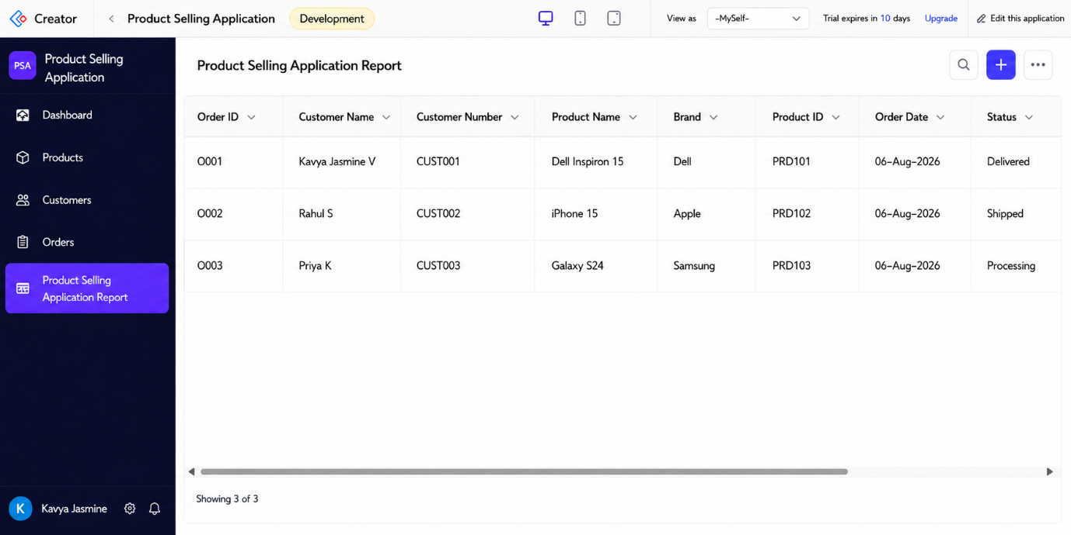
Result
The Product Selling Application using Cloud Service Provider (SaaS) was successfully developed. The system manages products, customers, and orders efficiently, automatically calculates the total amount based on quantity and price, and generates reports for sales management.

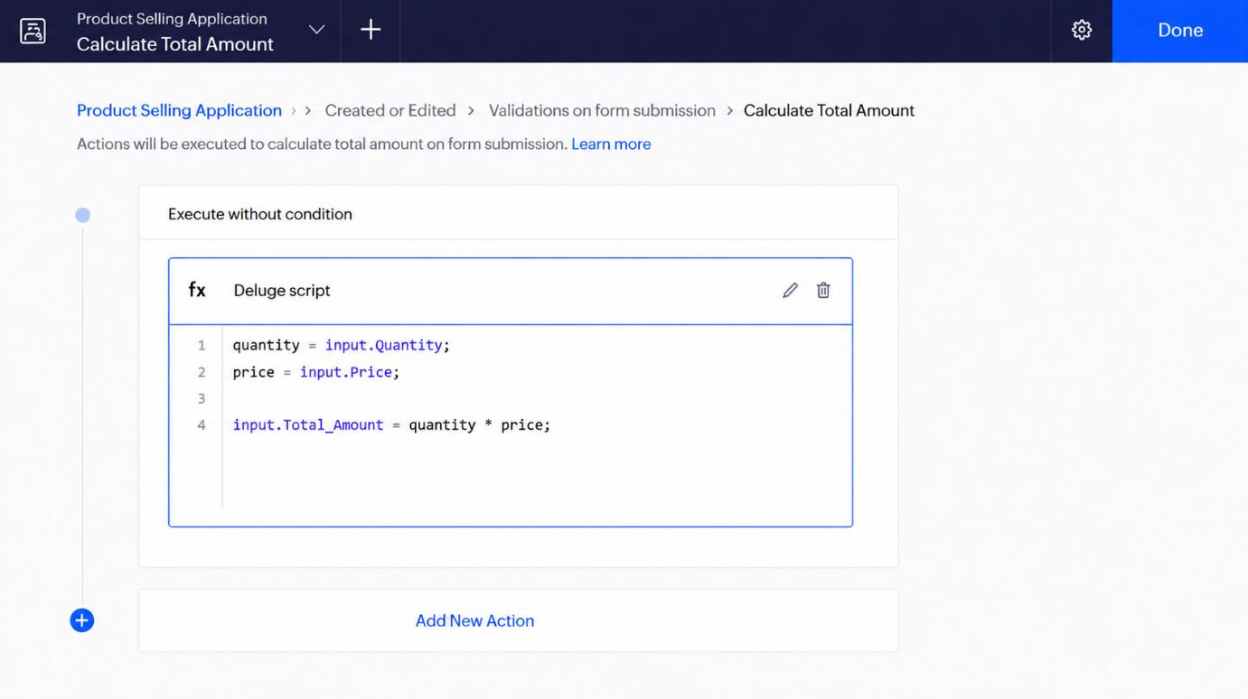
Result
The Product Selling Application using Cloud Service Provider (SaaS) was successfully developed. The system manages products, customers, and orders efficiently, automatically calculates the total amount based on quantity and price, and generates reports for sales management.

